**CRM Application for Jewel Management - (Developer)**

**College Name:** Shree Venkateshwara Arts and Science college Gobi.

**College Code**: brubd

**Team ID:** NM2025TMID20993

**Team Members:** 4

**Team Leader Name**: SWETHAVARSHINI N

**Email:** [swethavarshinin2023it@gmail.com](mailto:swethavarshinin2023it@gmail.com)

**Team Member**: DHANA SRI N

**Email:** dhanasri0707@gmail.com

**Team Member:** VENNILA S

**Email:** vennilas2023it@gmail.com

**Team Member**: OVIYA PRIYA R

**Email:** oviyapriyar2023it@gmail.com

**1.INTRODUCTION**

Project Overview:

A "CRM application form project document" isn't a standard term, but it likely refers to the documentation for a project that involves applying for a CRM software or a project to implement a CRM system, which is often in PDF format to standardize it and allow for easy sharing.

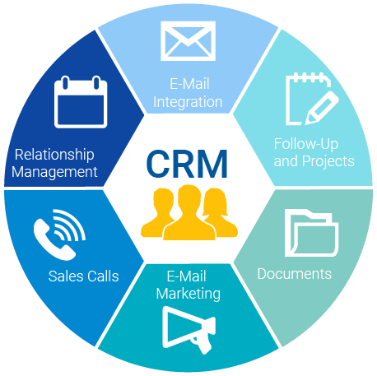

* **Purpose**:

Defines business challenges and desired outcomes, focusing on what needs to be achieved rather than just software features.

* **Contents**:
  + Articulates current business problems and inefficiencies.
  + Prioritizes key business outcomes.
  + Details user interface requirements (login, navigation, forms).
  + Specifies data fields, data types, and validation rules.

**DEVELOPMENT PHASE:**

Creating Developer Account:

By using this URL:  <https://developer.salesforce.com/signup>

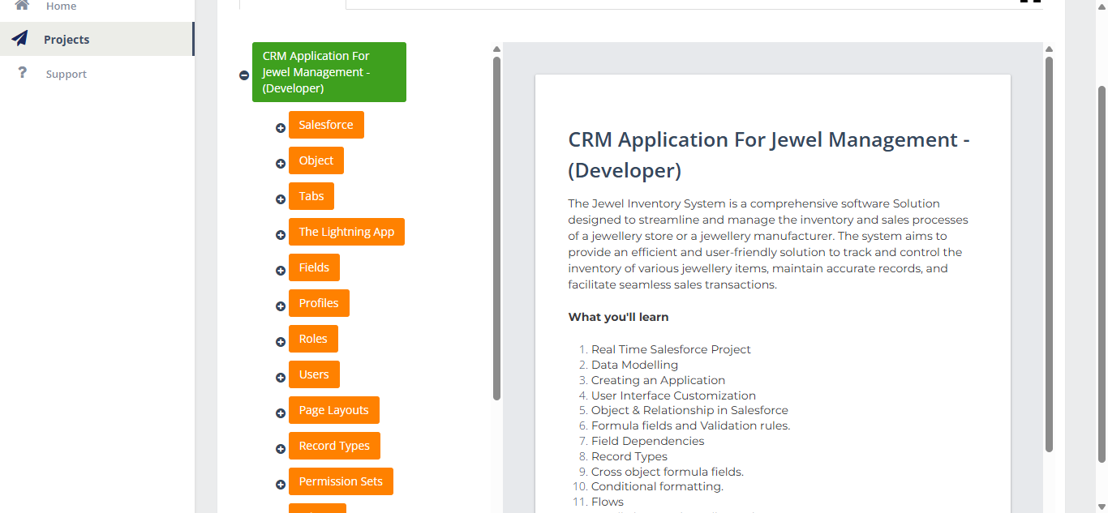

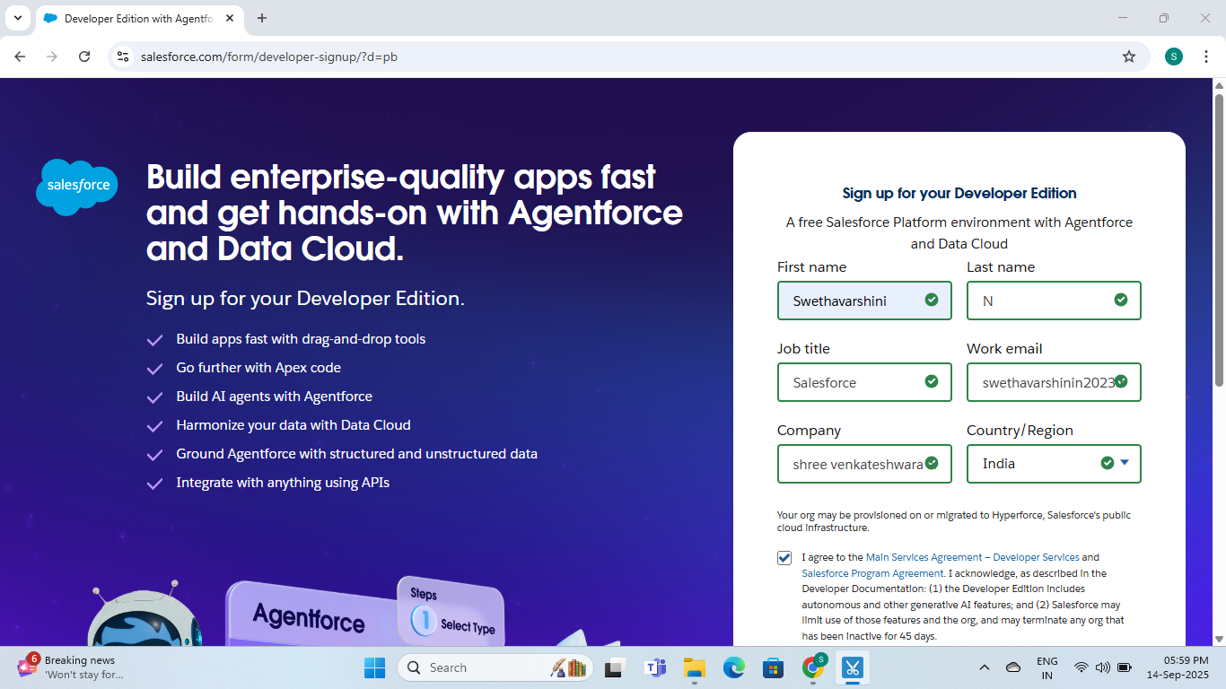

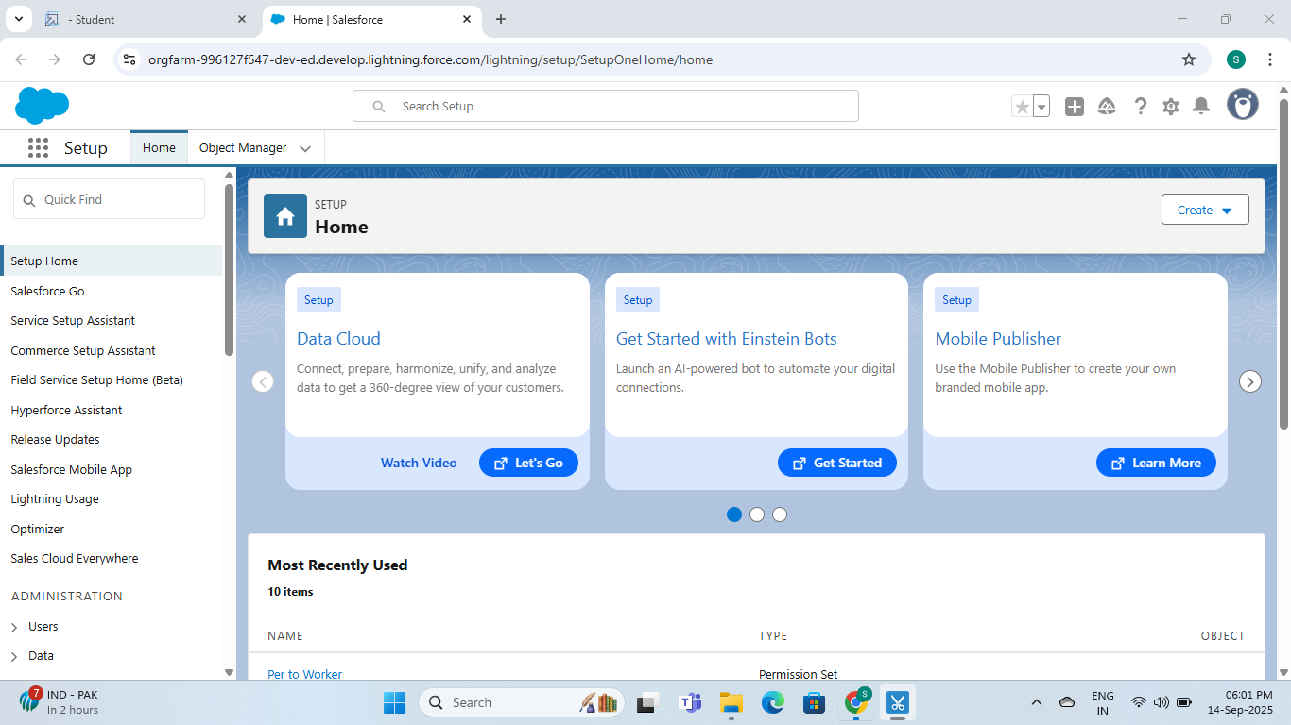

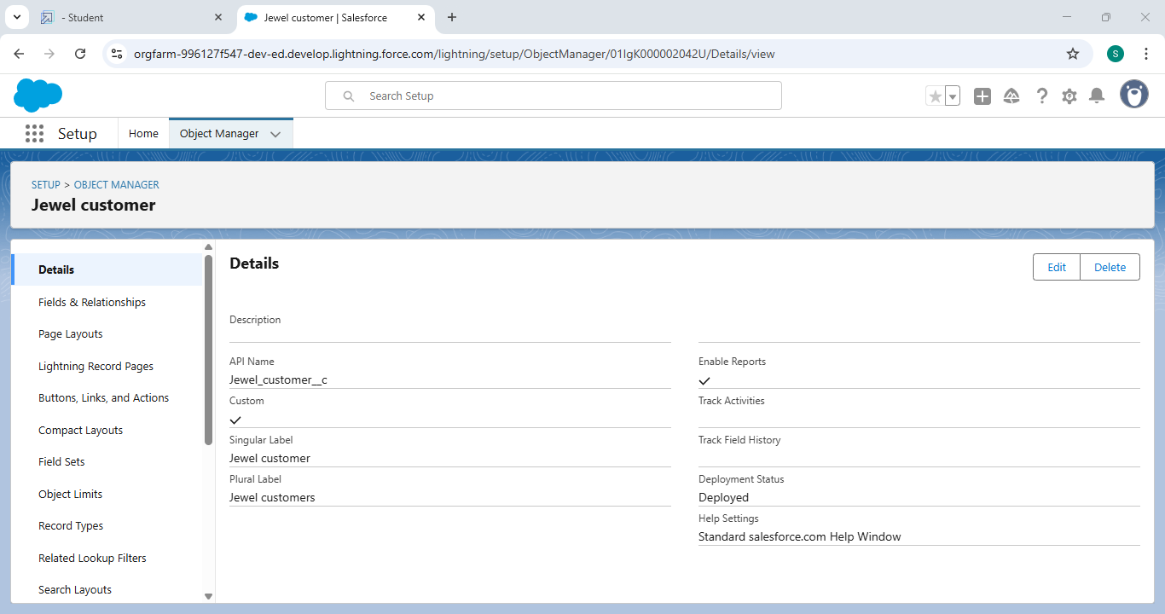

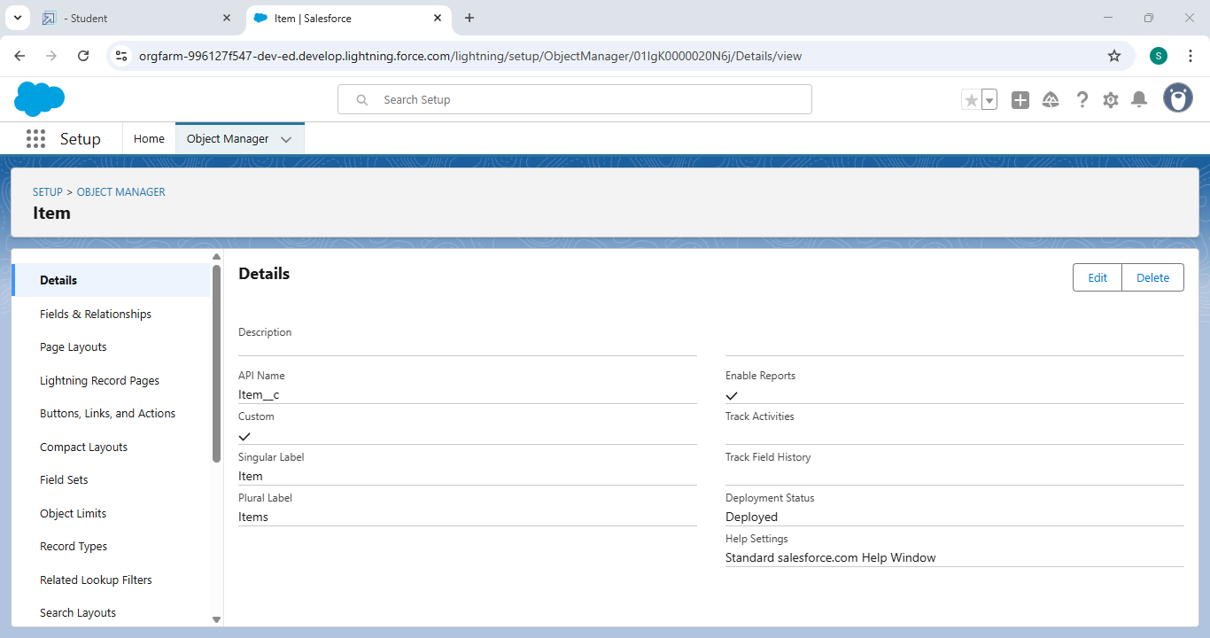

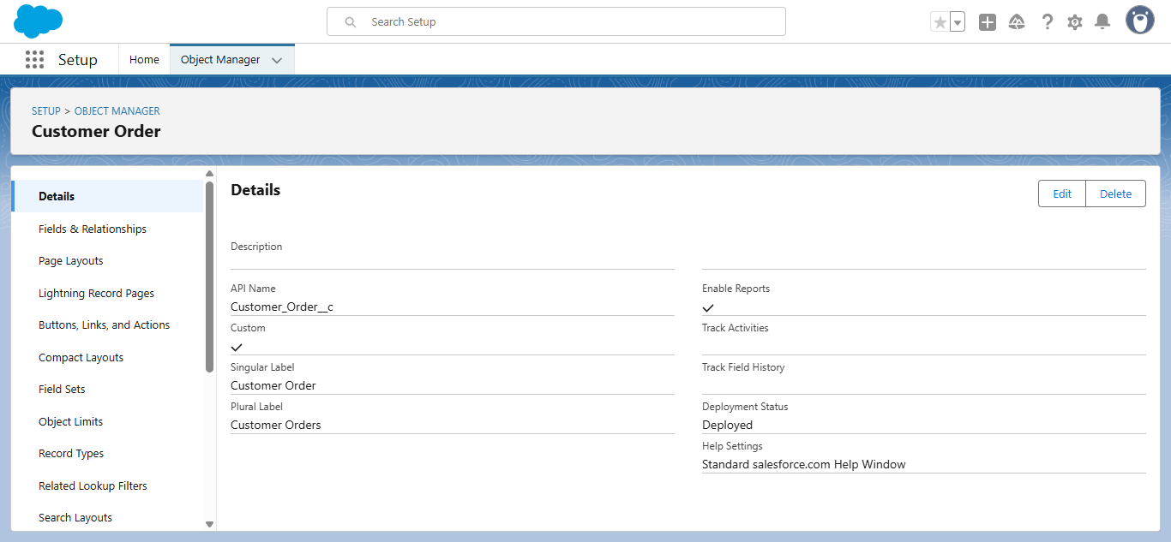

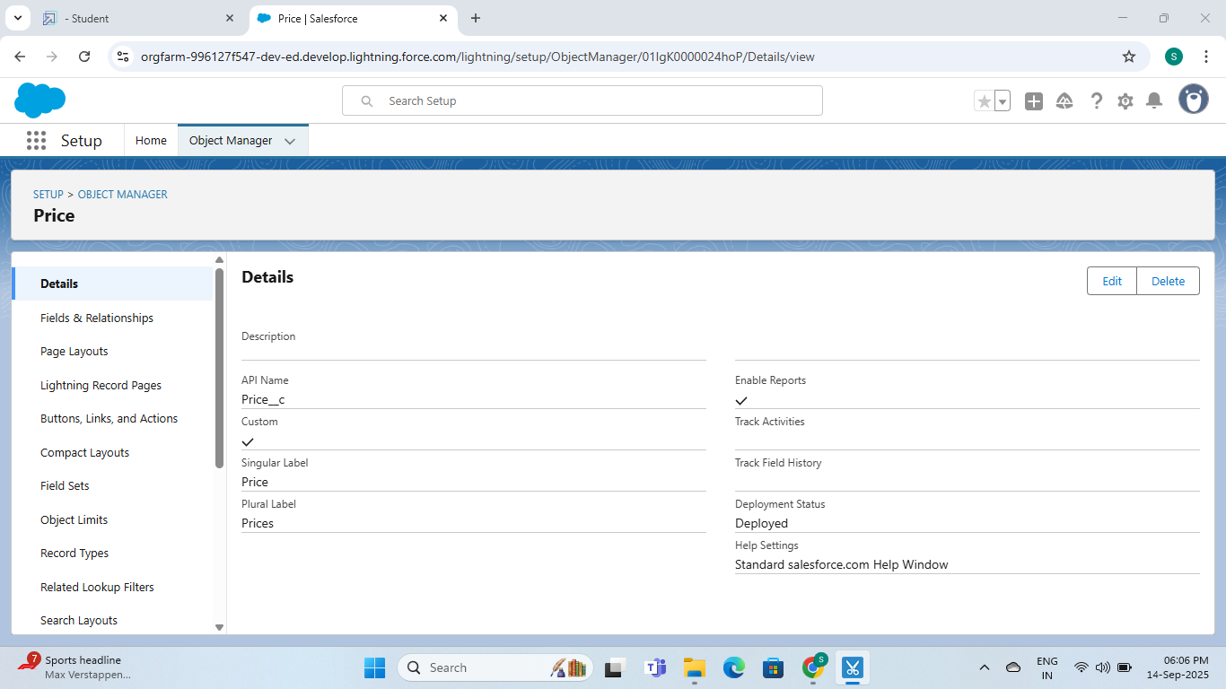

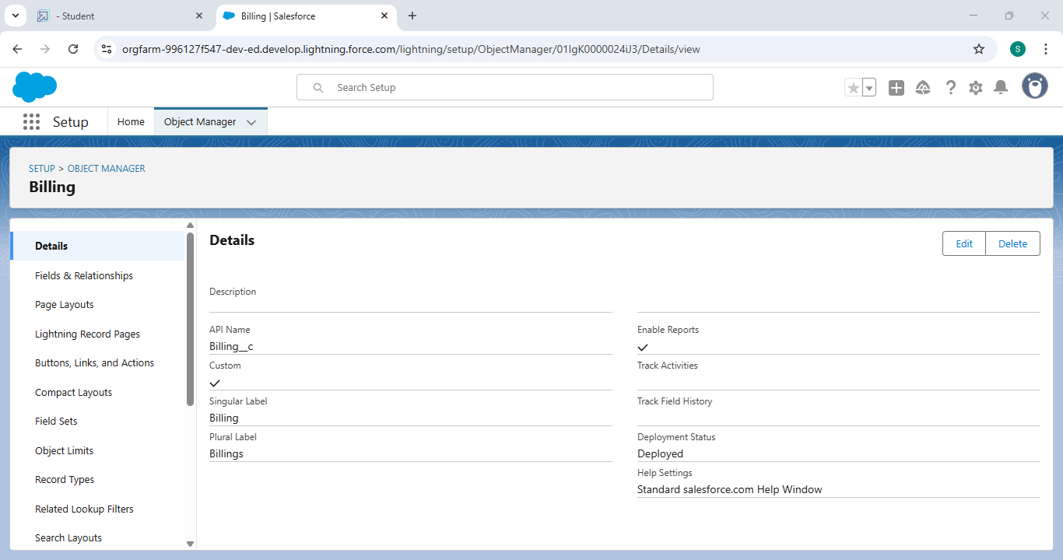

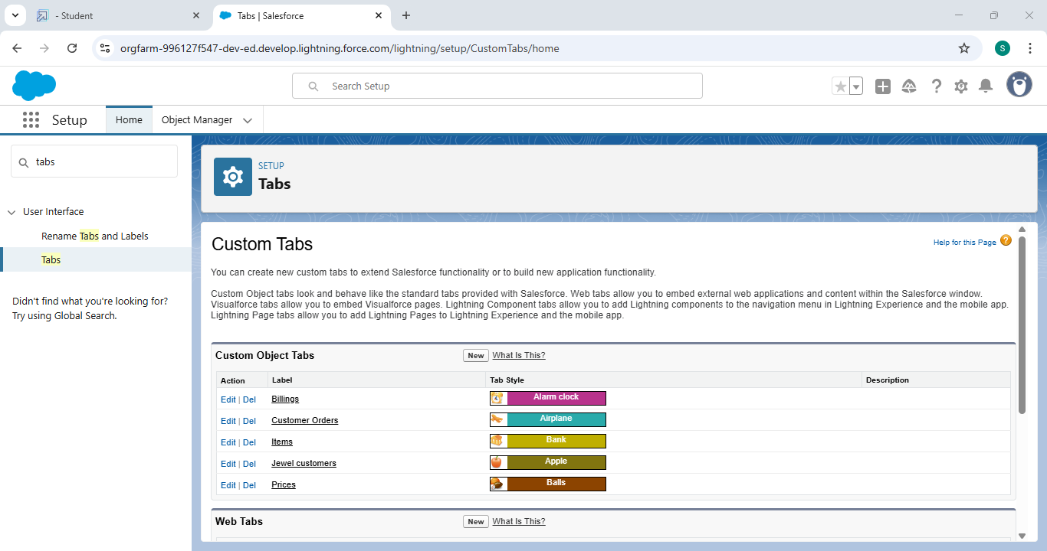

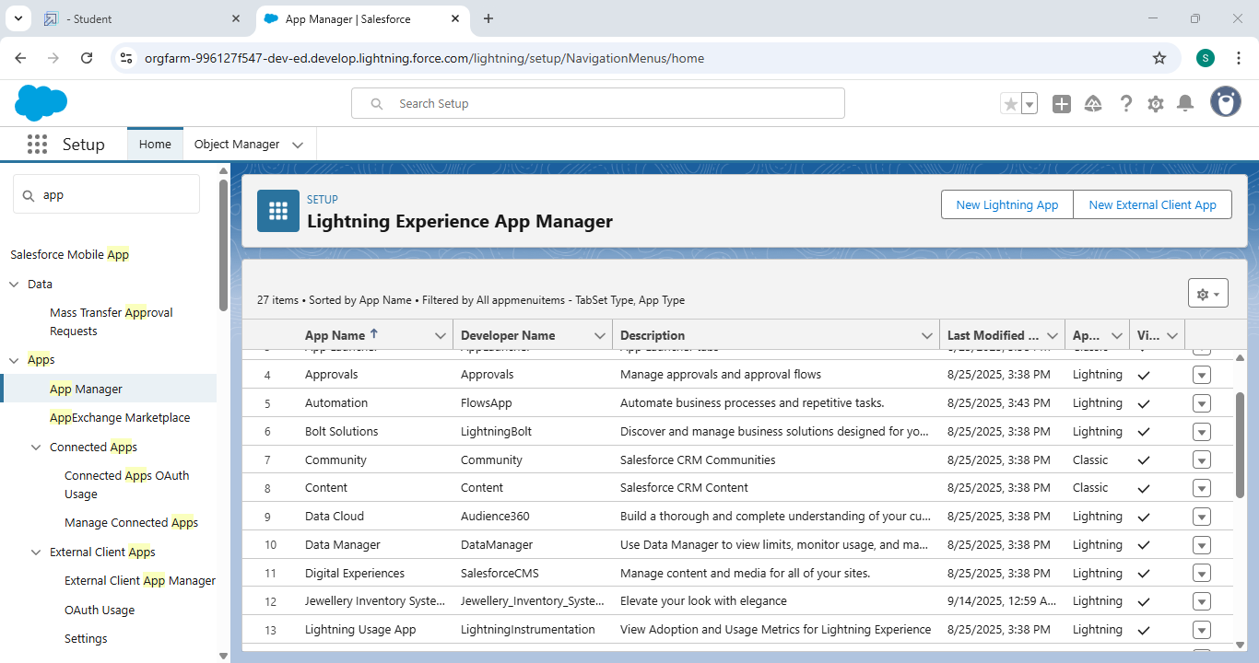

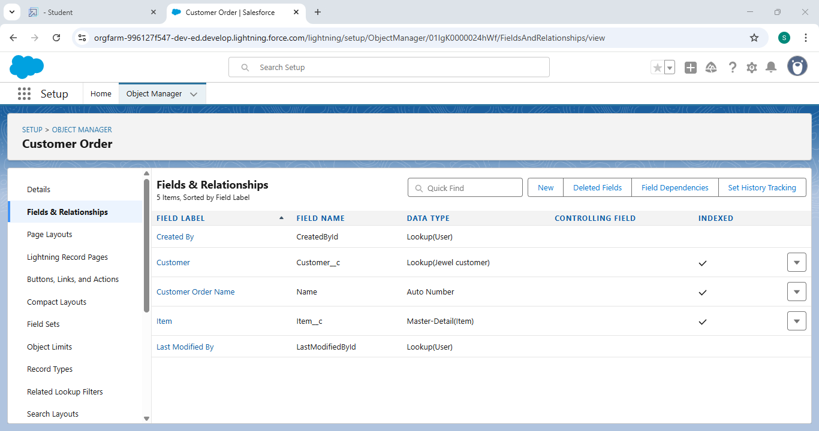

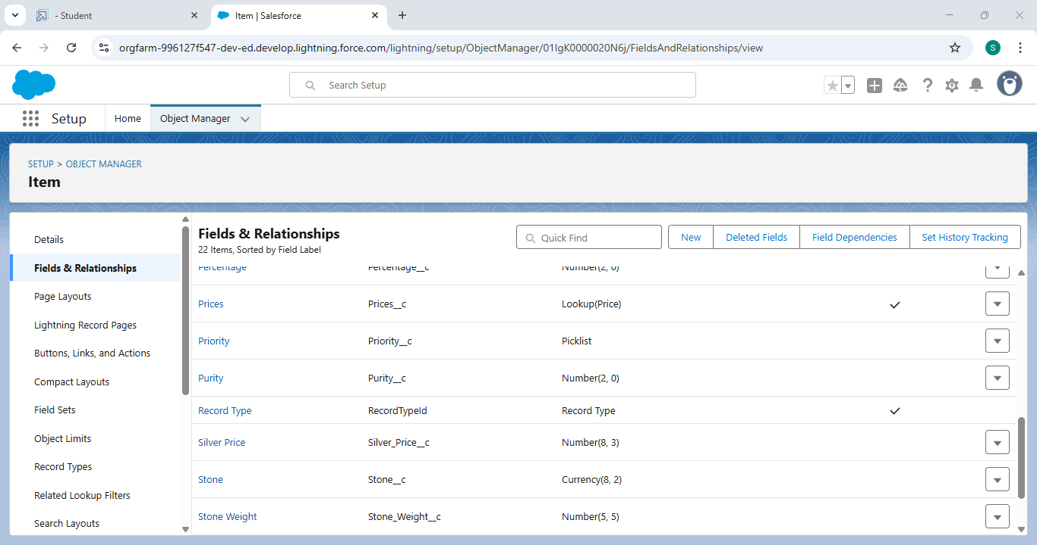

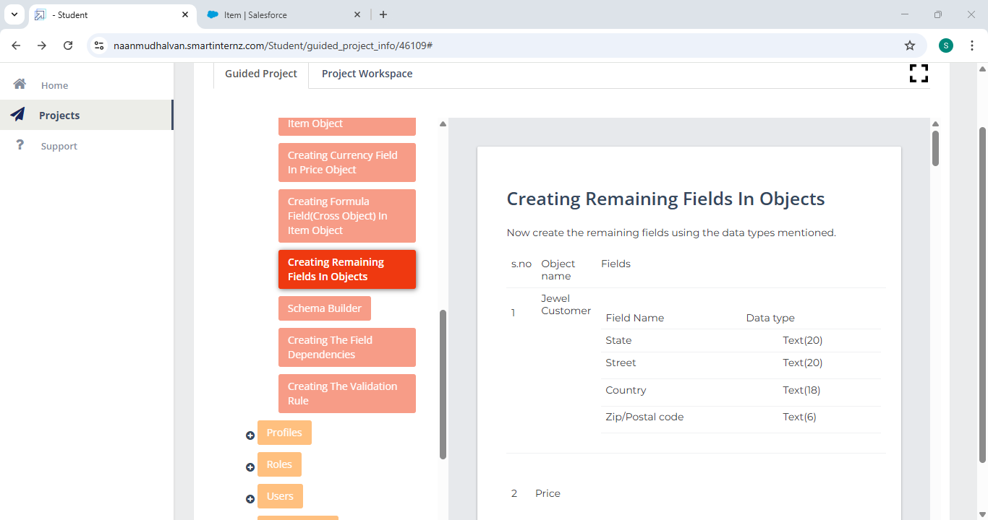

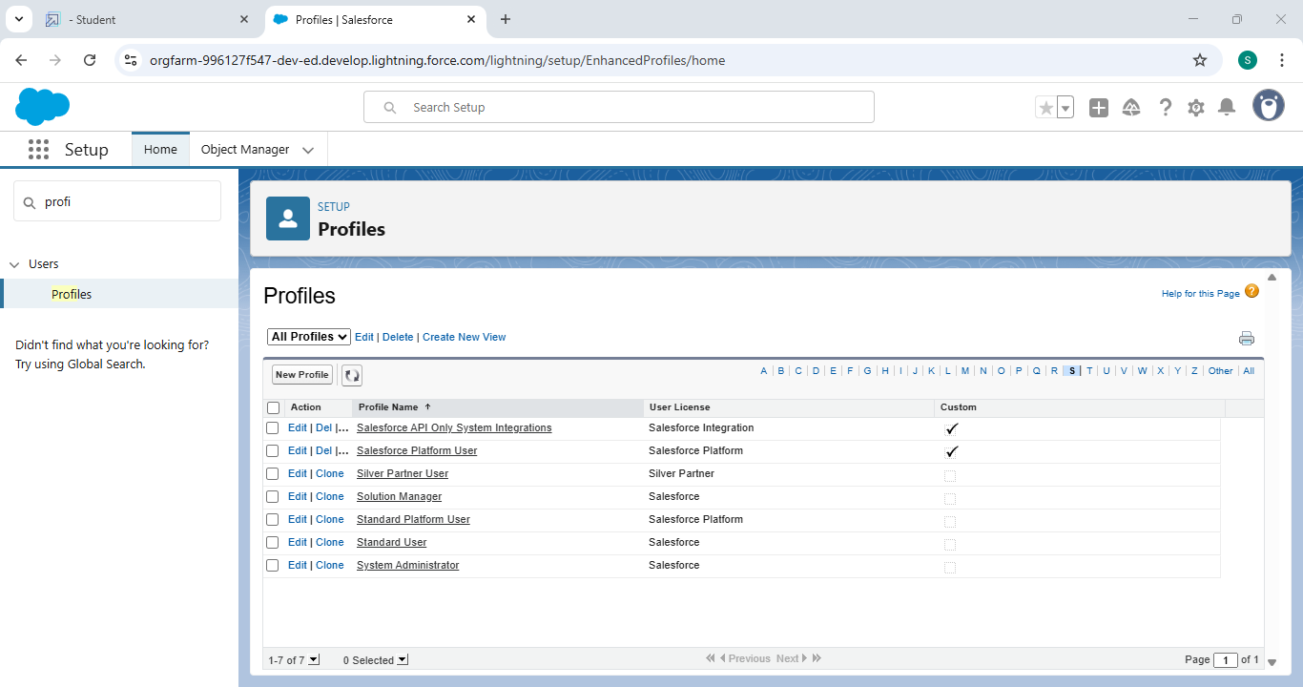

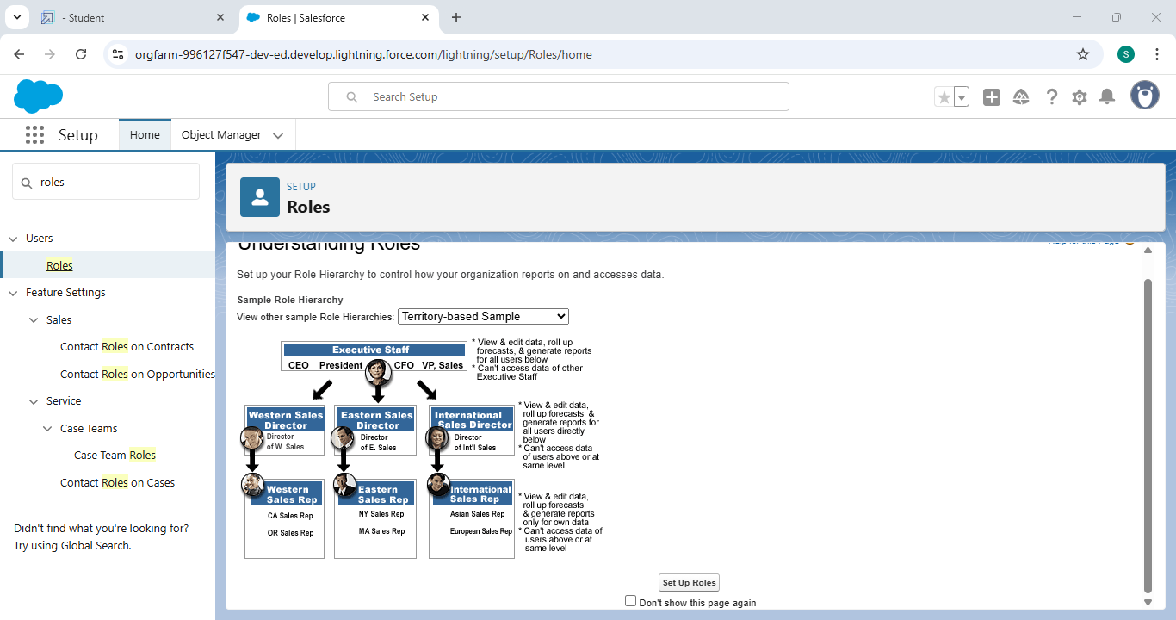

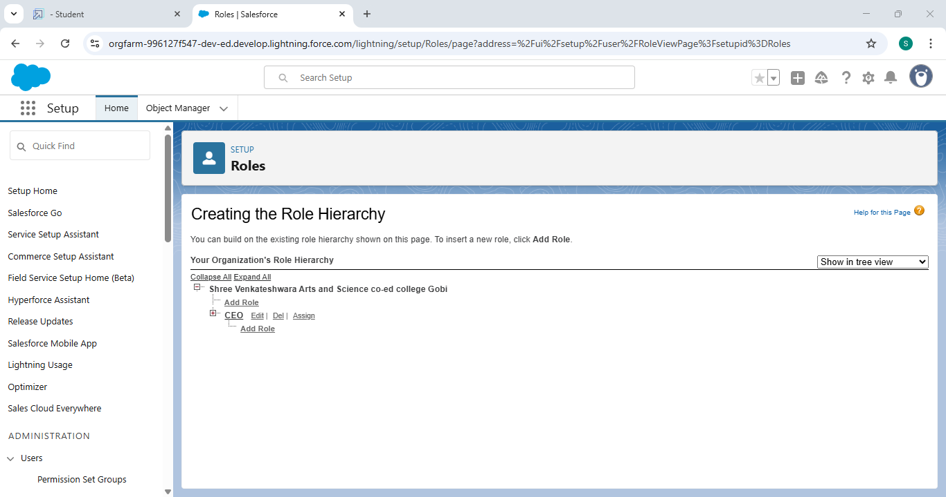

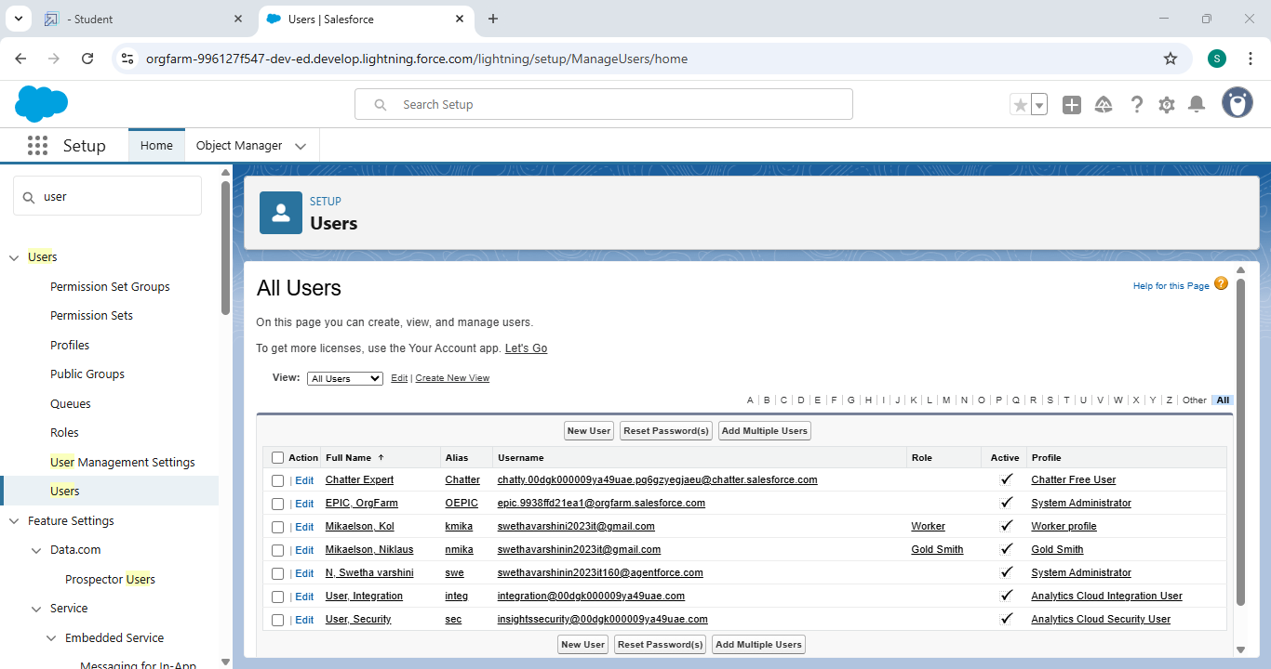

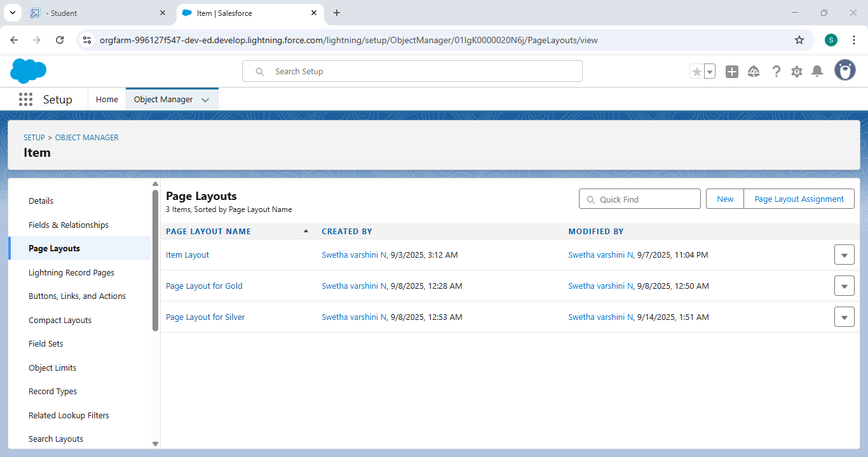

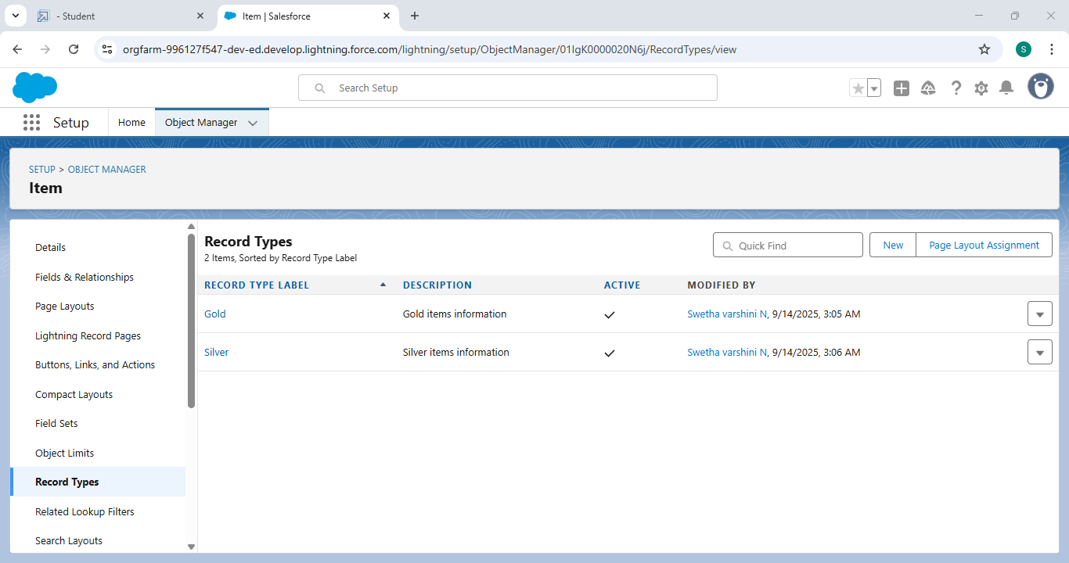

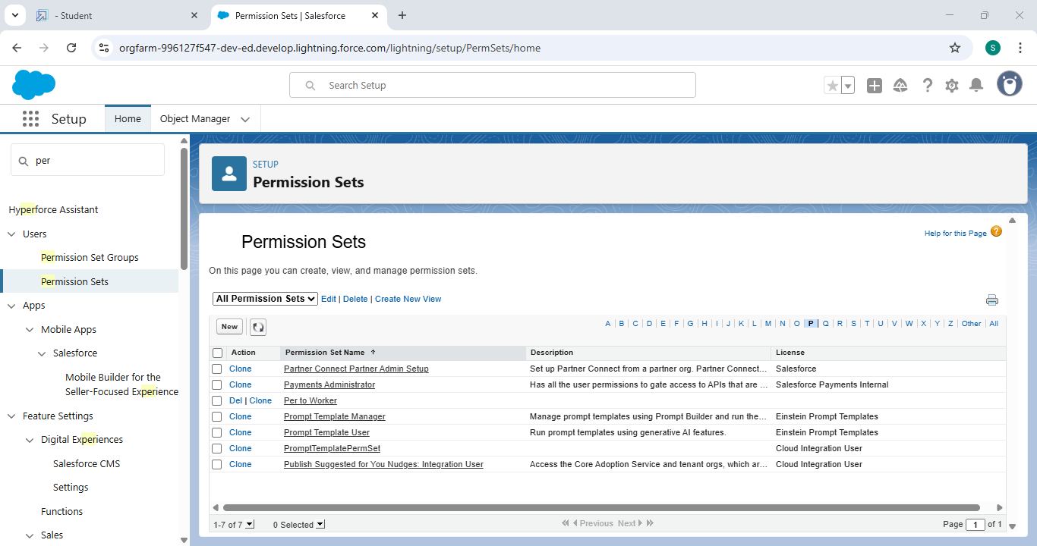

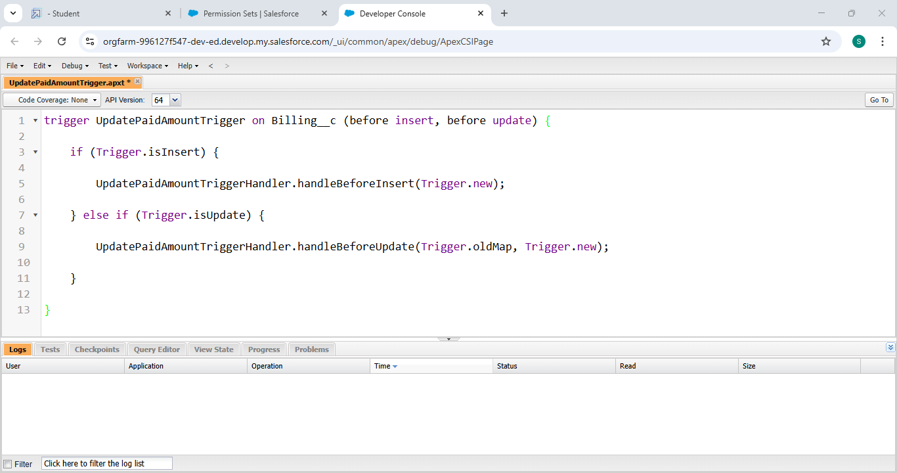

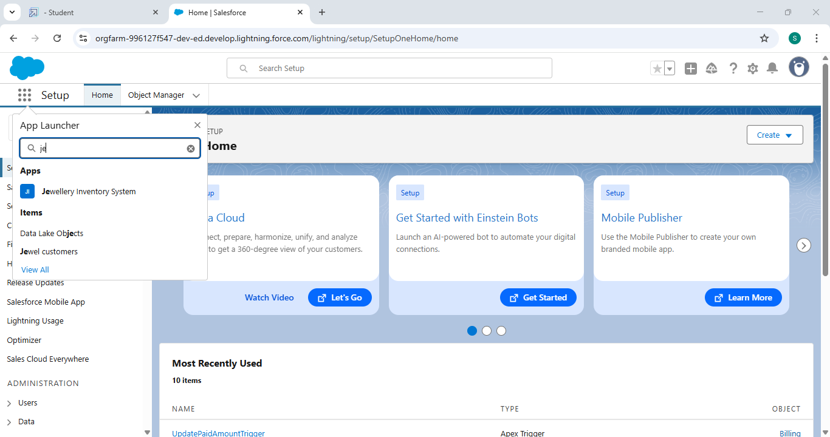

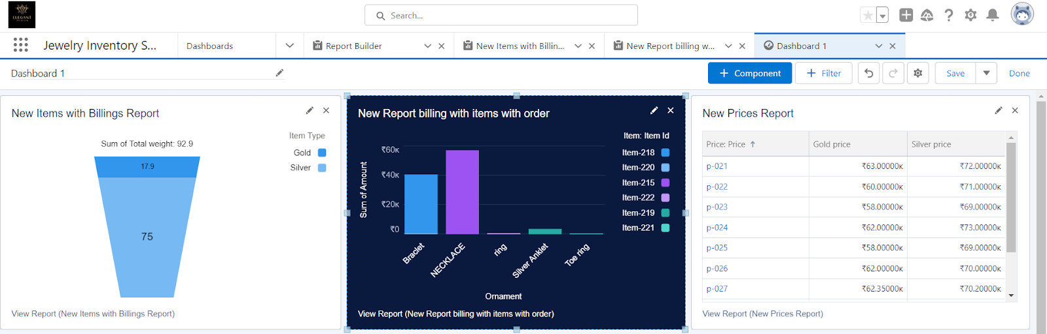

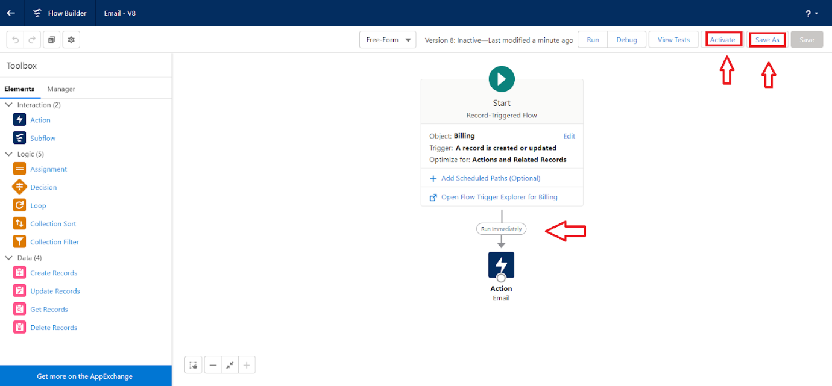

**Conclusion:**

Customer Relationship Management (CRM) is a strategic approach, supported by technology, to building and nurturing lasting customer relationships, which ultimately drives business growth, increases sales and loyalty, and enhances overall efficiency and customer satisfaction.